|  |
| --- |
| cid:0c9a3659-2c4f-4d40-9bfa-811260554716@eurprd08.prod.outlook.com Huge congratulations to our new deputy principal Ms. Emma Halstead. Wishing Ms. Halstead the best of luck in her new role. |

Welcome back to all our boys and girls and welcome to all our new junior infants, the children in our Rainbow Class and the children in our Sunflower Class. We are looking forward to a great year ahead with lots of learning, fun and friendship.

Please remember that there are no cars allowed in the car park except staff cars from any of the three schools on campus.



|  |
| --- |
| Parent meetings. Every year we hold a meeting in early September so you can see your child’s class and chat to the teacher and learn how the class will work. It’s a short meeting, about 15 minutes but it is a great opportunity to meet the teachers and other parents and ask any questions you might have.  **Junior Infants – Friday 16th September 11.45am**  **Senior Infants – Wednesday 14th September 9am**  **First Class – Wednesday 14th September 2.10pm**  **Second Class – Thursday 15th September 2.10pm**  **Rainbow room and sunflower room will meet as necessary** |

**We are looking for two new parent reps for our Board of Management, one male and one female. It is 6/7 meetings a year from 3pm – 4pm and it is possible to attend on zoom. Please give your name to Judie in the office if you’re interested. It’s a great opportunity to be involved in how the school is run.**

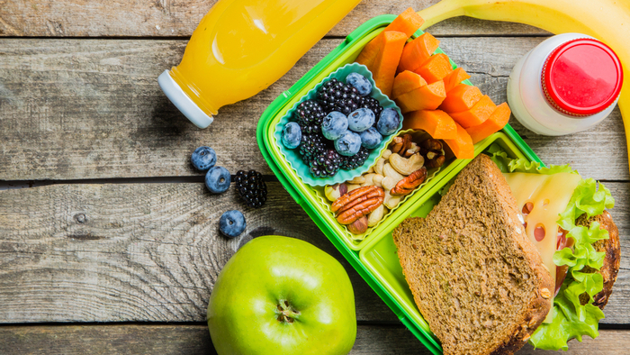

**Healthy Eating in school**

**If your child does not take the free school lunch please remember the items that they are not allowed to bring in**

### Crisps (including crisp-style snacks)

* Sweets
* Chocolate biscuits/bars
* Cereal bars with chocolate/ rice crispie bars
* Chewing gum
* Fruit winders
* Nuts
* Lollipops
* Fizzy drinks (including fizzy fruit-flavoured water, juices, etc)
* Any yoghurts with chocolate (Chocolate corners)

**Children are only allowed water or milk in school, no cordial or flavoured water allowed.**

 **Remember school starts at 8.50am.**

**Don’t forget to join Class dojo and don’t forget your lunch orders**