Welcome everyone to February’s newsletter. January has been a long month with lots of fun and hard work. We hope the weather is getting warmer and we’ll soon be playing in the field.
Make sure you’re signed up to class dojo or check out the school website www.loretojuniorprimarycrumlin.ie to see the work we’ve been doing and all the fun.
Art Exhibition.
The Art exhibition went really well with lots of parents and families calling in to see all the beautiful creations. Thank you to all the teachers, particularly Mrs Fitzgerald, who coordinated it. Thanks especially to the SNA’s who worked so hard to hang up all the pictures.
We are still collecting batteries for recycling in school. The competition goes on until March and we are waiting for our second collection of batteries. As a school community we are doing brilliantly so keep up the good work.

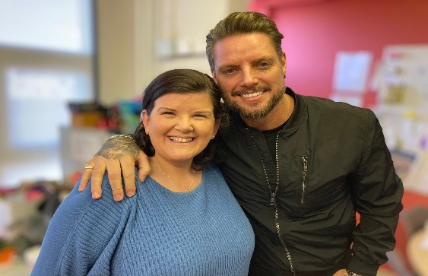

Keith Duffy (Boyzone) paid a visit to the school to film a documentary about teeth and the dentist. He talked to Ms Murray’s class and interviewed Ms Galligan. It will be on RTE sometime this year. We’ll let you know.

Time keeping and attendance
Just to clarify that the pizza party reward is only for First and Second class, we are only trialling it so we may start with Junior and Senior infants after midterm. The pizza will be a one off treat to encourage children to come to school. All the classes now have a pizza slice and the competition is heating up.

Cars driving through the gates.
I am asking parents, guardians, grandparents etc to please, please stop driving in through the gate in the mornings and afternoons. I know that it’s easy and others are doing it but I only care about the safety of the children in our school. A child can easily run across the road, as they are allowed to do and it only takes a second. PLEASE PLEASE think of the safety of ALL the children.
Thank you to all who are following the rules

REMINDER
School closed for Bank Holiday Monday 6th February
School Closed for Staff training on Wednesday 15th February
Mid Term Break Thursday 16th and Friday 17th February
School reopens Monday the 20th of February at 8.50am

