Welcome to our October Newsletter. We’ve all settled back in and are working very hard. It’s like the Summer Holidays never happened. Our Junior Infants are learning so much and we’re all enjoying being back in a good routine.
Attendance 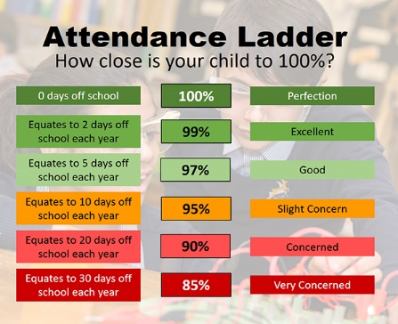

Every month we will send you a text with the number of days your

child has missed, this is an information

text so you can keep an eye on their

attendance. The more days they are in

school the more they will learn and achieve.

Maths Week in school 16th – 20th Oct 2023 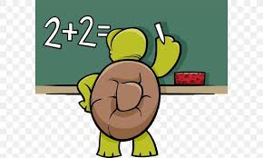
Parents are invited into classes at 1pm on Tuesday the 17th of October (Junior and Senior Infants) and 2pm on Thursday 19th October (1st and 2nd classes) to play maths games with your children. It is a lovely activity and one that the children love.
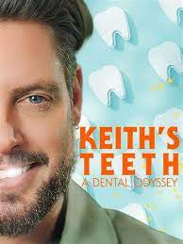 We’ve had lots of exciting TV appearances this month If you didn’t see Keith’s Teeth: A dental odyssey; have a look at it on RTE player. It’s always lovely to see our school on television and I am so proud of all the children.
Christmas Cards Don’t forget to drop back your Christmas card orders. They are a fantastic fundraiser and they look great. The children worked really hard on them.

Healthy lunches
Reminder of our healthy lunch policy. If you are not taking the school lunch please consider it. It’s a fantastic healthy option and really handy for parents. Children can now get ham every day if they want to.
If you are sending lunch please remember it must follow the same rules as school lunches. No chocolate yoghurts or yoghurts with chocolate sections, no sugary cereal bars or biscuits, crisps or chocolate. Only water or milk allowed.
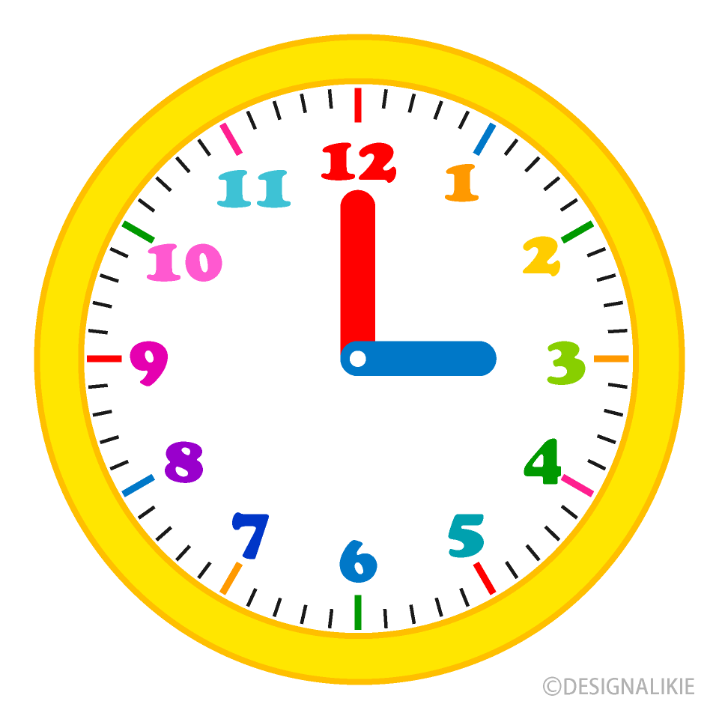 Remember school starts at 8.50am. Please, please try to be on time. Children are much more settled and ready for work when they start with everyone else. The morning is also a really important socialising time for them.

Halloween
October 27th – Children are allowed to dress up for Halloween.
Please remember no accessories (swords, staffs etc) and please remember to keep all costumes child friendly

Midterm is October 30th – November 3rd. 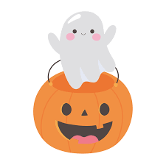
School reopens on Monday 6th November 2023

