Welcome to our April Newsletter
Welcome back from Easter Holidays. It’s the start of the Summer term and hopefully we’ll get dry weather so we can use the field for playtime.

Swimming
Swimming starts for second class this Thursday April 11th for 6 weeks. It’s always such a fun activity and the children love it and really benefit from it. We’re going to walk to Crumlin pool and get a bus home.
Easter Raffle Thank you to everyone who supported our Easter Raffle this year. We raised €670. All of the proceeds go towards ICT in the school as every classroom now has an interactive whiteboard. We appreciate all the support.
Winners
Lillian McGuinness R2 Malakai Lamera R8
Jacob Kenny R 10 Lilly Alexander R6
Lorcan Kenny R 1 Riley O Brien R5
Flynn Harris R7 Freya Dunphy R4
Sadhbh Dunphy R3 Sean McGuigan R 5
Mollie Farrelly R10 Sarah Hamilton R 8
Anna Tyrrell R 3 Tadhg Smit R2
Theo O Brien R3 Clarke Byrne R11
Adam Stany R12

April is World Autism Awareness Month. On April 26th we are all invited to wear red clothes and bring in €2 for AsIAm. We will have a number of other events in school to celebrate the month and to help us all learn a little more about Autism.
World Book Day. World Book Day is April 23rd. Parents are invited in that week for Story time. We will confirm days later on in the month. We will also have a story teller coming to visit and some classes will dress up as the favourite character from a book.

First Holy Communion
The first Holy Communion takes place on May 18th and it’s an important day for many of our second class pupils. We are inviting the boys and girls and their families back to the school for tea and cake so they can see their friends and take pictures etc. We will be asking First Class families to bring items to help with this. It will be a lovely day and we hope the sun shines.
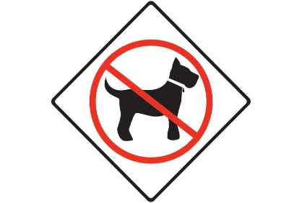
Please remember that dogs are not allowed in our school yard. There are a lot of people, both children and adults, who are afraid of dogs and it is unfair to have dogs around them. I am also not prepared to risk a dog biting someone, no matter how gentle a dog is. Please, please respect this rule.

REMINDERS:
April 23rd School Closed for New Maths Curriculum training for all staff
Monday 6th May – Friday 10th May: School closed for Mid Term break

