Welcome to our March Newsletter
It is hard to believe that we are coming to the end of our second term in school, Easter is only around the corner!! There is a lot happening this month in school and lots of fun to be had. Don’t forget to check out our website www.loretojuniorprimarycrumlin.ie for lots of photos.

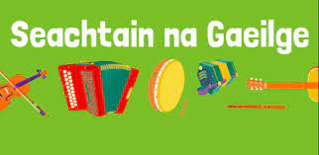
March 13th - 17th 2023
We will be making a huge effort to speak in Irish that week. There will be games, quizzes and prizes and on Friday March 15th we will have a La Glas and a Hollai so Halla. The children can wear green clothes and the parents are invited to join us for a SHORT performance in Irish in the hall.
Junior Infants 12.30
Senior infants 1pm
First class 1.30
Second class 2pm
All are welcome and bring your cupla focail ~~~~~~~~~~~~~~~~~~~~~~~~~~~~~~~~~~~~~~~~~~~~~~~~~~~~

- For all making First Holy Communion - First Confession will take place on Wednesday 6th March in school.

Easter
We will have an Easter egg hunt on the last day before Easter and children can wear their own clothes. School will finish at 12pm that day. There will also be an Easter raffle and tickets will be on sale from the 4th of March.
1 strip €2, 3 strips for €5.
All proceeds go towards ICT in the school.

With the weather being so changeable please make sure your children have a coat with a hood in school every day. We aim to go out to the yard every day as it’s so important for the children but sometimes we get caught in a shower. Hopefully we’ll be in the field in the sunshine in no time.

Reminders:
School closed this Friday March 8th for election
St Patrick’s Day Bank Holiday 18th March School Closed
Easter Holidays Friday March 22nd School closed at 12pm
School reopens Monday April 8th at 8.50am.

