Welcome to our June Newsletter
I can’t believe this is the last newsletter of the year. Second class are almost off to Senior Primary school and our junior infants are so grown up. It’s not long until our Summer Holidays.

First Holy Communion – 27th May 2023

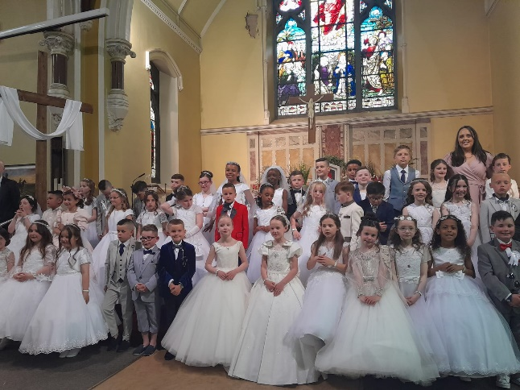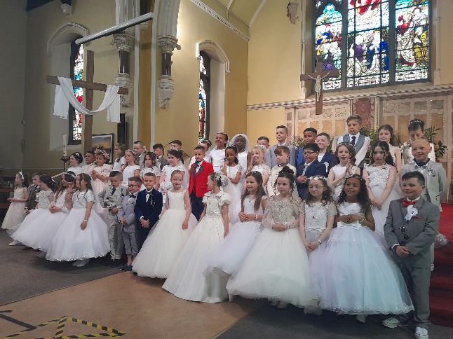

The First Holy Communion took place last Saturday in Dolphin’s Barn Church. It was a great day, the sun was shining and all the children looked fantastic. Lots of people came back to school to a party and it was great fun. Thanks so much to everyone who helped make it such a special day. To the teachers, the First class parents who brought treats for the party and the second class parents who prepared their children so well. Special thanks to Deirdre Mullen McGuinness (and Lillian and Grace) who helped organise the day.

