Welcome to February’s newsletter. January has been a long month with lots of fun and hard work. We hope the weather will soon clear up and we’ll be able to play in the field.
Make sure you’re signed up to class dojo or check out the school website www.loretojuniorprimarycrumlin.ie to see the work we’ve been doing and all the fun.
Art Exhibition.
The Art exhibition was a great success and it was fantastic to see all the wonderful creations. It was lovely to see so many parents and families coming to see the Art. Thank you to everyone who helped prepare the hall for the exhibition and to everyone who attended.

Cars driving through the gates.
Thank you to the majority of parents who do not drive into school in the mornings and afternoons. It’s great when the school community can work together to help keep our children safe.
If anyone is still considering driving in, please remember how quickly an accident can happen and how small many of our children are.

Time keeping and attendance Well done to all the classes who have received a pizza slice on the attendance board. Attendance is definitely improving and I’m really proud of how hard everyone is trying. Remember that the days add up very quickly and every minute counts in the children’s education.

St Patricks Day – Hoolaí sa Halla – Friday March 15th
All are welcome to our St Patrick’s Day parade and party piece which we call the Hoolaí sa Halla. It will be a maximum of 20 minutes. The children can wear green that day.
Junior Infants: 12.30 – 12.50
Senior Infants: 1pm – 1.20pm
1st Class: 1.30 – 1.50pm
2nd Class: 2pm – 2.20pm.
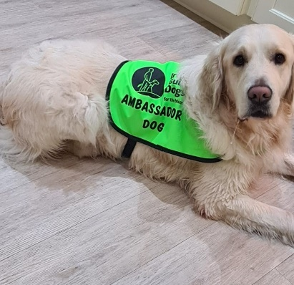
Paddy is Ms Halstead’s dog and he has been chosen as an ambassador for the Irish Guide dogs. He visited us last week and the children loved him. Ms Halstead will bring him to school regularly. He is super friendly and calm.

Open Day
On Wednesday February 21st we will have an open day for all the local creches and preschools so they can see our fabulous school and what we have to offer. All prospective families are welcome so please spread the word

REMINDER
Mid Term Break Thursday 15th and Friday 16th February
School reopens Monday the 19th of February at 8.50am
School closed for Election Friday 8th March

